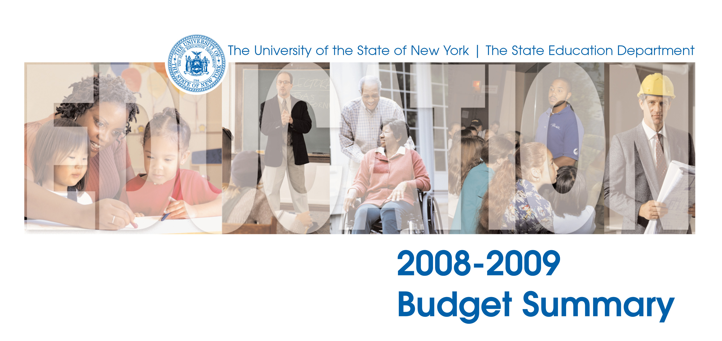
2008-2009
Regents Budget Proposal

January 2008

THE UNIVERSITY OF THE STATE OF NEW YORK

Regents of The University

Robert M. Bennett, Chancellor, B.A., M.S. Tonawanda
Merryl H. Tisch, Vice Chancellor, B.A., M.A., Ed.D. New York
Saul B. Cohen, B.A., M.A., Ph.D. New Rochelle
James C. Dawson, A.A., B.A., M.S., Ph.D. Peru
Anthony S. Bottar, B.A., J.D. Syracuse
Geraldine D. Chapey, B.A., M.A., Ed.D. Belle Harbor
Arnold B. Gardner, B.A., LL.B. Buffalo
Harry Phillips, 3rd, B.A., M.S.F.S. Hartsdale
Joseph E. Bowman, Jr., B.A., M.L.S., M.A., M.Ed., Ed.D Albany
James R. Tallon, Jr., B.A., M.A. Binghamton
Milton L. Cofield, B.S., M.B.A., Ph.D. Rochester
Roger B. Tilles, B.A., J.D. Great Neck
Karen Brooks Hopkins, B.A., M.F.A. Brooklyn
Natalie M. Gomez-Velez, B.A., J.D. Bronx
Charles R. Bendit, B.A. Manhattan

President of The University and Commissioner of Education

Richard P. Mills

Deputy Commissioner for Operations and Management Services
Theresa E. Savo

The State Education Department does not discriminate on the basis of age, color, religion, creed, disability, marital status, veteran status, national origin, race, gender, genetic predisposition or carrier status, or sexual orientation in its educational programs, services and activities. Portions of this publication can be made available in a variety of formats, including Braille, large print or audio tape, upon request. Inquiries concerning this policy of nondiscrimination should be directed to the Department’s Office for Diversity, Ethics, and Access, Room 530, Education Building, Albany, NY 12234.

The Regents Plan for the Next Stage of Educational Reform

For a decade, student achievement has improved in response to Regents policy and local action. But the improvement is not sufficient. The achievement gap has narrowed but not closed. The world has also changed as billions of people have entered the global economy and ignited a global education boom. Every society that can afford to do so is moving urgently to improve knowledge and skill and close their own version of the achievement gap. The Regents will engage with statewide and local partners on the actions below, adopt or recommend policy as appropriate, and, with the State Education Department and all of USNY, seek improved results systemwide:

Students | - Promote a sustainable early education program for all students. Resolve issues of standards, funding and service delivery for young children.  - Improve academic outcomes for children with disabilities by setting performance targets, promoting effective practices, and holding schools accountable for dramatic improvements.  - Improve outcomes for English Language Learners by setting performance targets, promoting effective practices, and holding schools accountable for dramatic improvements.  - Improve high school attendance and graduation rates by setting performance targets, promoting practices that remove barriers to graduation, and holding schools accountable for dramatic improvements.  - Report student persistence and college completion results, and increase investment in programs that have been shown to remove barriers to graduation.
Systems | - Raise the learning standards to exceed global standards to graduate all students ready for citizenship, work, and continued education. Align standards, assessments, curriculum and instruction across P-16, emphasizing transitions.  - Strengthen instruction. Define, reduce and then eliminate the inequitable distribution of teaching talent. Require all teachers of core academic subjects to be highly qualified in the subject they are teaching by July 2007. Improve teacher retention. Focus professional development on effective practices in areas in which academic needs are greatest. Accelerate the integration of technology into teaching and learning practices in P-16 institutions.  - Advocate for a Foundation Formula to provide State Aid that is adequate, sustainable, fair, and commensurate with the cost of education that enables students to meet the standards.  - Strengthen the capacity of the State Education Department to support schools as they work to improve student achievement and the Department’s capacity to hold them accountable for doing so.  - Create a P-16 student data system to drive improvements in graduation rates in high school and higher education.
Structures | - Reduce barriers to teaching and learning in high need schools by creating a vision and leadership framework for an integrated education, health and mental health collaboration. Promote strategies found to be promising in resolving high incident health and mental health problems among children.  - Create P-16 Councils to advise the Regents on actions to strengthen USNY and improve student outcomes dramatically at each transition point in the P-16 system.  - Focus regional education networks on joint P-16 strategies and actions to improve student outcomes.

The Regents Approach: The Principles

The Regents propose this plan for the next stage of educational reform to accomplish the six USNY aims. As the Board and the State Education Department act to implement its plan, we commit to do so in a manner that is consistent with the following principles:

The Aims of the University
of the State of New York (USNY)

- Every child will get a good start.
- Every child will read by the second grade.
- Everyone will complete middle level education ready for high school.
- Everyone will graduate from high school ready for work, higher education, and citizenship.
- People who begin higher education will complete their programs.
- People of all ages who seek more knowledge and skill will have the fullest opportunity to continue their education.
November 2005 Education Summit
- We will confront the data, share it broadly, and use it to define as precisely as possible where resources and energy should be applied. We will recognize the achievements and also declare the problems as clearly as we can.

- We will engage everyone by listening to the people the education system is supposed to serve, to parents, to the educators at every level, to the employers, and to the elected officials who must weigh enormous competing demands for scarce resources. In particular, we will engage students and their parents, and the wider community because educational institutions do not belong to the educators but to the people. We will create a communications plan to listen to, inform, and involve people statewide.

- We will define measurable objectives so that others can hold us accountable, and we can hold education leaders accountable for improving results.

- We will study the practices of high performing education systems, states and nations, and adapt the best to New York’s situation. We will examine what actions are most effective, and invite others to learn with us.

- We will take action focused on systematic change to effect sustained improvement. We know, for example, that closing the achievement gap for students requires correcting the unequal distribution of teaching talent. And we know that in demanding change in educational institutions to achieve better results, we must also build capacity in our own State Education Department to take on its part of this improvement strategy.

- We will continually renew the alignment of our actions to ensure coherence and effectiveness. For example, academic standards, curriculum, assessment, and instructional practice have to be aligned to be effective. When one element changes, all other elements must be examined to ensure that the system remains effective.

- We will strengthen USNY, because it has great potential to build more effective transitions for students from one level of the system to the next.

- We will advocate for State and federal financial resources and legislative actions that will help achieve better educational outcomes. And we will be accountable for the effective use of those resources.

Regents Budget Priorities
(Increase in Millions)

IMPROVE ACHIEVEMENT FOR STUDENTS IN
GREATEST NEED
State Aid $ *
Regional Education Alliances $ 135.1

* The Regents proposed a State Aid increase of $1.94 billion in October. Subsequent data updates produced greater than expected increases. To support the principles of Foundation Aid and continue to provide constructive advice to decision makers, the Regents in January considered an alternative phase-in and other adjustments to improve the focus on high need districts.

REDUCE AND THEN ELIMINATE THE INEQUITABLE
DISTRIBUTION OF TEACHING TALENT $ 6.84

IMPLEMENT YEAR 2 OF THE P-16 ACCOUNTABILITY $ 9.0

STRENGTHENING STUDENT SAFETY $ 1.45

IMPROVE ACHIEVEMENT BY INCREASING ACCESS
TO MUSEUMS, CULTURAL INSTITUTIONS AND
ON-LINE LIBRARY SERVICES $ 72.3

ENABLE MORE INDIVIDUALS WITH DISABILITIES
TO LIVE AND WORK INDEPENDENTLY $ 5.0

Details on Regents Budget Priorities
(Increase in Millions)

IMPROVE ACHIEVEMENT FOR STUDENTS IN GREATEST NEED FTE

- Regional Education Alliances
  - P-16 Regional Education Alliances (Page 3) $ 15.0 8
  - Smart Scholars Program (Page 5) $100.0 6
  - Family and Parent Outreach (Page 6) $ 6.5
  - Planting the Seed (Page 6) $ 1.0 9
  - Expansion of Programs that Close the Student Achievement
Gap in Higher Education (Page 7) $ 12.6

REDUCE AND THEN ELIMINATE THE INEQUITABLE DISTRIBUTION
OF TEACHING TALENT

- Alternative Teacher Preparation Programs (Page 11) $ 6.84 3

IMPLEMENT YEAR 2 OF THE P-16 ACCOUNTABILITY

- P-16 Data System (Page 13) $ 2.0
- Digital Education: Technology to Advance Teaching and Learning (Page 15) $ 7.0 4

STRENGTHENING STUDENT SAFETY

- Addressing and Preventing Teacher Misconduct (Page 17) $ 1.45 19

IMPROVE ACHIEVEMENT BY INCREASING ACCESS TO
MUSEUMS, CULTURAL INSTITUTIONS AND ON-LINE
LIBRARY SERVICES

  - Cultural and Museum Education Act (Page 18) $ 30.0 5
  - Permanent Statewide Internet Library (Page 19) $ 10.0 3
  - Ensuring Care of Government Records and Cultural Resources (Page 20) $ 24.75 12
  - Cultural Resources and Resources for Literacy, Learning and
Workforce Development (Page 21) $ 7.55 28

ENABLE MORE INDIVIDUALS WITH DISABILITIES TO LIVE AND
WORK INDEPENDENTLY

  - Independent Living Centers (Page 22) $ 5.0

Total (excluding State Aid) $ 229.69 97

IMPROVE ACHIEVEMENT FOR STUDENTS IN GREATEST NEED - Regional Education Alliances

P-16 Regional Education Alliances

New York State and the State Education Department (SED) provide hundreds of millions of dollars each year to partnerships statewide. Many of these partnerships are dedicated to closing the achievement gap and exist in areas of poverty. It is time to galvanize their combined strength and coordinate their efforts. In this way we can expand and combine many of the partnerships and, at the same time, launch innovative new ways to reach all at-risk students and ensure they succeed.

The Regents propose establishing P-16 Regional Education Alliances in every high poverty community. Each one would be administered by a local council of partners from USNY institutions plus service organizations and employers. Alliances would form in designated areas of low achievement and high poverty. SED would encourage them to form, help them get started, and nurture them to grow. The Regents will consider proposing additional funds to ensure their success. Alliances would set performance targets, measure results, evaluate progress, and report annually to the public, the Regents, the Legislature, and the Governor.

The State’s 8 Literacy Zones would be included in the Regional Education Alliances. Based on the pioneering work of the Harlem Children’s Zone, the Regents and SED have established or currently help support Literacy Zones to offer coordinated services in severely distressed communities throughout New York. These Literacy Zones enable children, adults, and families to access a variety of existing community services that they might not otherwise be able to obtain. In a Literacy Zone, adult education strengthens eight primary partnerships essential for family and community success: education; business; labor and workforce; health and mental health; financial and economic development; arts and culture; community agencies and the private not-for-profit sector that provides services to families; programs for special needs populations; and the volunteer sector.

There are many successful examples of partnerships already funded through the Regents and State Education Department. Here are a few:

- Science and Technology Entry Program (STEP) increases the number of historically underrepresented and disadvantaged students who are prepared in mathematics, science, technology, health related fields and the licensed professions and therefore ready to enter college. Competitive grants are awarded to colleges and universities to work with schools and school districts with high enrollments of disadvantaged students. More than 50 institutions of higher

IMPROVE ACHIEVEMENT FOR STUDENTS IN GREATEST NEED - Regional Education Alliances

education throughout the State partner with local schools and districts to make this program a success.

- The North Country has a Science, Technology, Engineering and Math Partnership (STEM) that combines North Country BOCES with 18 school districts and Clarkson University and SUNY Canton, with others set to join. The purpose is to improve the quality of teaching in science, technology, and math; and to ensure disadvantaged students get the same kind of instruction and move on to college. Starting with one part-time person to raise funds, they have now attracted $15 million in funding from state, federal, and private sources. Most of that money comes in competitive grants through SED. Their programs now serve 6,500 students and 250 teachers.

- Literacy Zones: Founded in 1970, the Harlem Children's Zone (HCZ) is a non-profit, community-based organization that works to enhance the quality of life for children and families in some of New York City's most disadvantaged neighborhoods. The HCZ focuses not only on education, social service and recreation, but on rebuilding the very fabric of community life. Based on the pioneering work of the HCZ, the State Education Department established or currently helps support Literacy Zones to offer coordinated services in severely distressed communities throughout New York. These Literacy Zones enable children, adults, and families to access a variety of existing community services that they might not otherwise be able to obtain. In a Literacy Zone, adult education strengthens eight primary partnerships essential for family and community success: education; business; labor and workforce; health and mental health; financial and economic development; arts and culture; community agencies and the private not-for-profit sector that provides services to families; programs for special needs populations; and the volunteer sector. Literacy Zones, partly supported through SED, currently operate in the following eight locations: Buffalo, Rochester, Syracuse, Onondaga County, Schenectady County, Bedford-Stuyvesant (Brooklyn), the Bronx, and Long Island City/Western Queens. The Regents are considering expanding the number and the scope of Literacy Zones throughout the State. Such an expansion would require a concomitant increase in State funding.

Requested Resources:

$15 million in new State funds to the P-16 Regional Education Alliances to expand the State’s Literacy Zones. An additional $5 million in federal Adult Education funding will be provided for competitive grants.

The following are innovative new programs that would enhance the work of P-16 Regional Education Alliances:
IMPROVE ACHIEVEMENT FOR STUDENTS IN GREATEST NEED - Regional Education Alliances

Smart Scholars Program The Regents propose a Smart Scholars program that would transform the traditional 4-year high school to college model. This $100 million initiative in new State funding would provide at least 12,000 disadvantaged students the support to graduate from high school on time and complete college in three years. The program would target annually up to 12,000 students who:
- Have been identified as academically at-risk for not successfully completing high school or for succeeding in college;
- Have historically not had access to or success in higher education; and
- Do not have the financial resources to go to college without tuition assistance.

This comprehensive program builds on the work of College Now, Early College High School Programs, and SUNY and independent colleges in providing college courses to high school students, plus the active work of the Department’s opportunity programs to assist students who are educationally at-risk to graduate from high school and achieve success in college. This is a proven program that ensures students excel, according to a comprehensive study by Columbia University researchers.

This Dual Enrollment program can work in many cases through the Regional Education Alliances described above that will link colleges, school districts, BOCES, and other educational and community organizations and agencies to provide additional academic support dedicated to students beginning as early as the ninth grade, and enabling students in grades 11 and 12 to take early college courses so that by graduation from high school, these students will have completed the necessary coursework to enter a baccalaureate program at the second-year level. This will result in increased high school graduation rates and early college graduation.

Costs of both public and private higher education in this country has been rising steadily, and in many cases, putting the hope for a college degree out of the financial reach of both low and middle income students and their families. From 2000 to 2006, New York colleges increased tuition and fees on average from 19 percent for two year CUNY institutions to 45 percent for four year independent institutions. Other institutional sectors fall within this range. More is needed to ensure that students who historically have not had access to or success in higher education can be appropriately prepared, be successful and complete the program at a cost which their families can afford.

Requested Resources:
$100 Million and 6 FTE.
IMPROVE ACHIEVEMENT FOR STUDENTS IN GREATEST NEED - Regional Education Alliances

Family and Parent Outreach

Longitudinal analyses conducted over a 15-year period at Yale University show that students achieve more when schools work with parents and families. Family and Parent Outreach can accomplish this goal by linking families to schools beginning at birth; helping parents understand and participate in the Contracts for Excellence; and creating resources so that parents can support their children’s learning through a working knowledge of the State learning standards, State assessments, individual Student Progress Reports, School Leadership Report Cards, and School Progress Report Cards. This can be accomplished by connecting Regional Alliances to Family Welcome Centers, which already exist in the eight Literacy Zones that have been created. This will extend the outreach significantly.

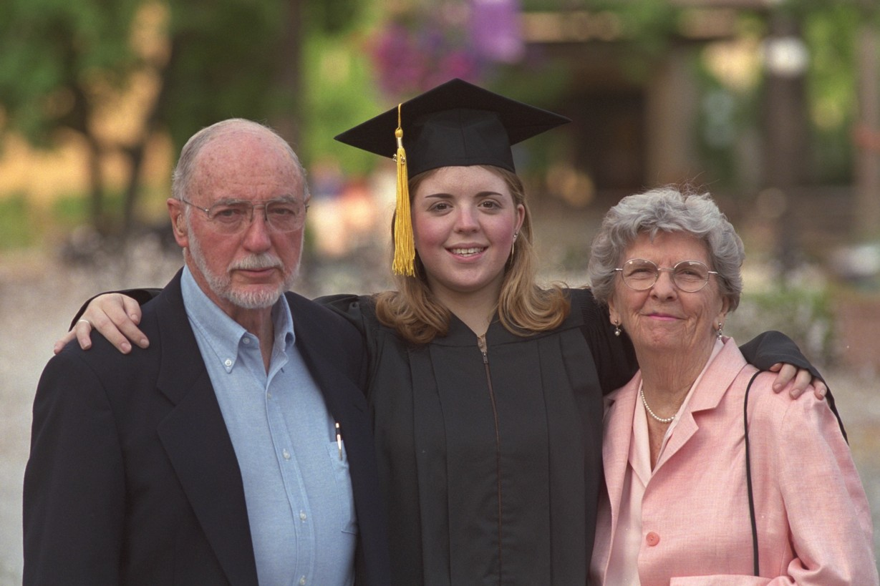
Requested Resources:

$6.5 Million

Planting the Seed

This program has two key components to ensure that more at-risk middle and high school students learn about college and professional opportunities through guidance counselors and through members of the professions themselves. First, members from the 750,000-strong professionals licensed by the Board of Regents will reach out to at-risk students and mentor individuals. Second, students and their counselors, parents, and teachers will have a single website that provides key information about career options, educational requirements, and links to college programs, financial aid, and grants available to students. Nothing else now exists to provide this kind of comprehensive information to students.

Many of the other programs proposed by the Regents and described in the following pages rely on the proven partnership approach described above. Regional Education Alliances can provide an excellent catalyst to increase their power. Examples of such programs include the expanded Alternative Certification Program, the proposals for Digital Education and Cultural Education, and the proposed expansion of Career and Technical Education.

Requested Resources:

$1 Million and 9 FTE
IMPROVE ACHIEVEMENT FOR STUDENTS IN GREATEST NEED - Regional Education Alliances

Expansion of Programs that Close the Student Achievement Gap in Higher Education

New York State has many existing successful partnerships between P-12 and Higher Education that help close the achievement gap in higher education and increase access for students who are historically underrepresented in higher education. These partnership programs reduce the drop-out rates for students at risk of dropping out of high school; provide academic and counseling services to support student success in middle school, high school and college; provide financial assistance to attend college; increase college graduation rates for minority and economically disadvantaged students; and prepare students for careers in science, mathematics, technology and the licensed professions.

Increasing the investment in these programs will permit more students to participate in the programs and benefit from the services provided.

The State Education Department is asking for an additional appropriation for these successful partnerships in the amount of $12.6 million to expand the programs to serve more students.

The Liberty Partnerships Program (LPP) was established to address the significant dropout rate among New York’s youth. The failure of many young New Yorkers to complete their secondary education limits their opportunity for a life of fulfillment, prevents them from advancing into postsecondary education and hinders the State’s efforts to provide a well-trained workforce for business and industry in New York. LPP offers comprehensive pre-collegiate/dropout prevention programs and services to students enrolled in grades 5-12 to improve their ability to graduate from high school and enter postsecondary education and the workforce. The Science and Technology Entry Program (STEP) prepares historically underrepresented or economically disadvantaged secondary school students for entry into postsecondary degree programs in scientific, technical, health-related fields, and the licensed professions.

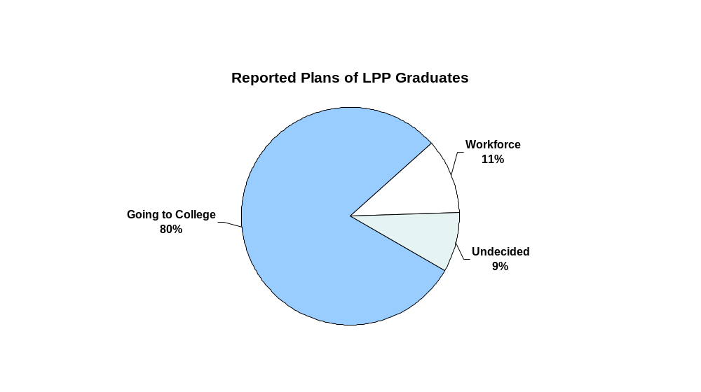
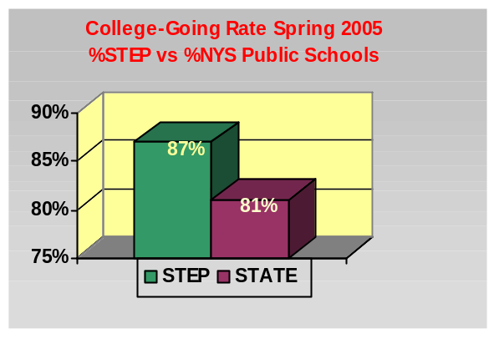

IMPROVE ACHIEVEMENT FOR STUDENTS IN GREATEST NEED - Regional Education Alliances

The Higher Education Opportunity Program (HEOP) and the Collegiate Science and Technology Entry Program (CSTEP) help to close the performance gap by providing financial assistance, supplemental instruction, internships, and counseling to students who otherwise might not pursue postsecondary education. HEOP provides access and success for students who show potential for postsecondary study but who would not be readily admitted to a college or university without HEOP financial and academic support. CSTEP continues the work begun through the STEP program and provides college and university students with learning opportunities in mathematics and science, as preparation for advanced study in professional careers.

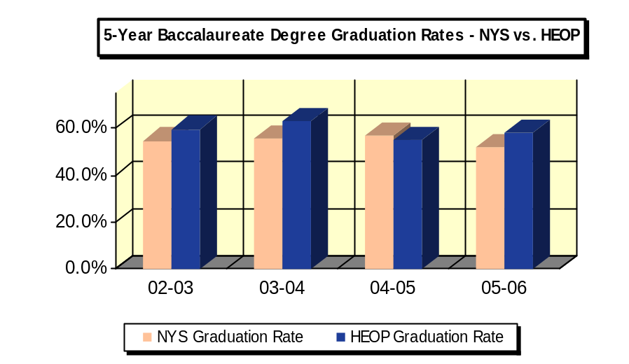

Requested Resources:

The additional $12.6 million would be divided among the programs in this way:

- HEOP: An increase of $4.5 million for a total appropriation of $29,737,000
- STEP and CSTEP: An increase of $2.5 million for a total appropriation of $21,500,000 (60% goes to STEP and 40% goes to CSTEP)
- Liberty Partnerships Program (LPP): An increase of $5.6 million for a total appropriation of $18,125,000
IMPROVE ACHIEVEMENT FOR STUDENTS IN GREATEST NEED

Short -Term Behavioral Assessment and Treatment Units

- Provide intensive evaluation and behavioral intervention for students with the most severe behavior disorders.
- Short-term (3-6 months) length of stay.
- Promote placement of students in less restrictive settings.
- Reduce placement of students with autism and severe developmental disabilities out of State.

Out of State Placements | Projected # of Students to be Served in Three Years | Projected Savings
837 | 100 students | $2.1 Million

Requested Resources:

No State funds are requested. Federal funds are being used for this initiative.

IMPROVE ACHIEVEMENT FOR STUDENTS IN GREATEST NEED -
Improving Core Instructional Practices for Students with Disabilities

Response to Intervention Programs and Professional Development to Technical Assistance Providers

- Improve technical assistance to school districts on research-based instruction.
- Intervene early and prevent students at risk of reading difficulty from falling behind.
- More appropriately identify students with learning disabilities.
- Reduce classification rates with resulting savings to State Aid projected at $1.4 million after 2008-09.

Results for Students with Disabilities

Year | Graduation  Rates | Dropout Rates
2007 Results | 38% | 19%
2010 Target | 52% | 15%

Requested Resources:

No State funds are requested. Federal funds are being used for this initiative.
REDUCE AND THEN ELIMINATE THE INEQUITABLE DISTRIBUTION OF TEACHING TALENT

Alternative Teacher Preparation Programs

Despite improvements, the Regents still find an inequitable distribution of teaching talent in New York. Students in high poverty schools are more likely to have teachers who are not highly qualified in the subjects they teach than students in low need schools. In 2005-2006, over 14,400 teaching assignments in New York State (7% of all teaching assignments) were held by teachers without appropriate certification. These assignments were in every subject area.

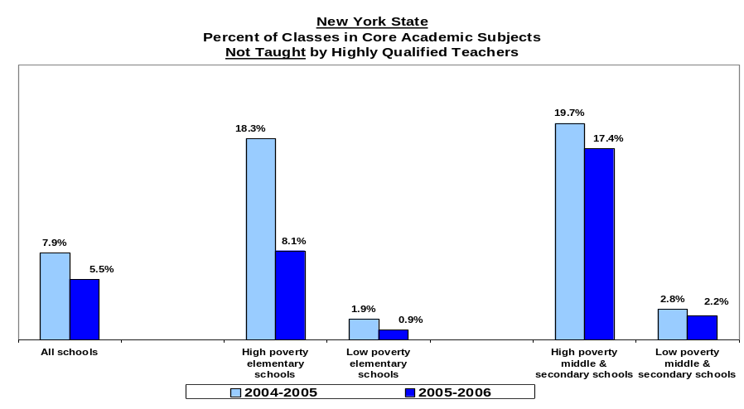

In 2005-2006, high-poverty schools had over 5 percent of
core classes not taught by highly qualified teachers,
due mainly to teachers without appropriate certification

The Regents will consider a proposal to prepare 1,000 new teachers within three years in subjects where there are shortages and for children in greatest need. This would be accomplished by expanding the proven Alternative Certification program and also the traditional teacher education program in the context of eight P-16 alliances that will be supported through competitive grants. Here are important elements of the proposal:

- Challenge grants are essential to assemble and sustain an effective P-16 partnership involving schools, colleges and universities.
- P-16 alliances and teacher education programs supported by this proposal must have or develop particular competence in urban and rural education where needs are greatest.
- A P-16 alliance reflects the Regents recognition that teachers are not prepared by higher education alone but through a joint effort of recruitment, preparation, student teaching, placement, retention, and continuous professional development that
REDUCE AND THEN ELIMINATE THE INEQUITABLE DISTRIBUTION OF TEACHING TALENT

- involves both teacher preparation programs and the P-12 schools in which the teachers work.
- Alternative certification is well established in New York. The Regents have supported research by James Wyckoff and colleagues to evaluate the efficacy of alternative certification in relation to other pathways to the teaching credential. Regents policy has provided the foundation for alternative certification since 2000.
- Effective practice, including classroom management strategies, will be part of the teacher education program.
- Alliances will be supported as a group through opportunities to learn teacher retention practices.

Requested Resources:

$6.84 Million first year ($25 Million over three years) and 3 FTE.

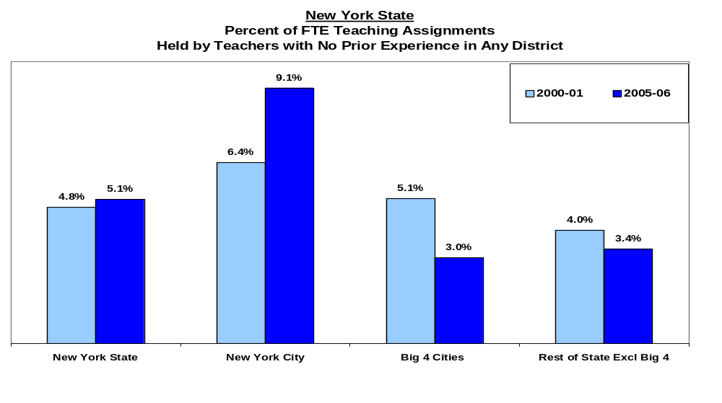
IMPLEMENT YEAR 2 OF THE P-16 ACCOUNTABILITY

P-16 Data System

The New York State Education Department (SED), with the leadership of the Board of Regents, and the partnership of the City University of New York (CUNY), the State University of New York (SUNY), New York City Department of Education (NYCDOE), the Big 5 schools and BOCES District Superintendents, have embraced an ambitious P-16 reform strategy to ensure comprehensive, unified efforts to improve student achievement at all levels.

The education partners have committed to the design of a comprehensive data system across all sectors of the State’s education system, from pre-K through higher education (P-16). Currently, there is an array of different data systems maintained by multiple entities, including local school districts, BOCES, SED, and individual institutions of higher education, including SUNY and CUNY. Connecting P-16 data statewide could provide educators with information about students from their earliest years of education, as well as their patterns of achievement over time. This information can be used to improve student persistence and graduation.

The Regents have contracted with Parthenon Group to perform the strategic planning for a P-16 data system. Parthenon Group is coordinating the work between the partners to do this initial data analysis and system design.

Expected Gains:
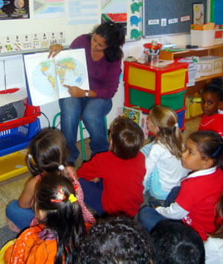
The outcomes for a fully-implemented P-16 Data System will be to:
- Provide a unified view of student achievement from year to year across the P-16 system.
- Support programmatic actions to raise student achievement by giving early indications of problems and where to apply resources, new practices, and innovations.
- Support policy changes and resource investments.
- Identify the value added by programs at every level.
- Build on and combine the strengths and achievements of existing data systems and accountability measures.
- Be secure, accurate, and timely.

IMPLEMENT YEAR 2 OF THE P-16 ACCOUNTABILITY

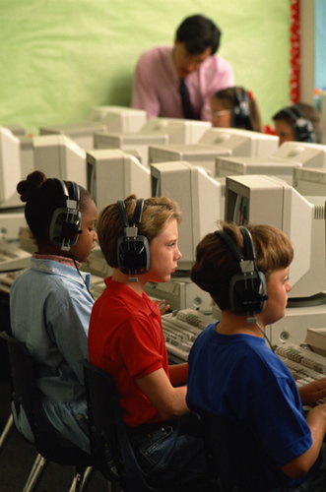
Requested Resources:

$2 million for work during the data analysis phase with SED’s current data systems to prepare for a full P-16 system:

- Eliminate duplicate data collection; improve and consolidate links between current data systems. Link teacher certification data (TEACH) to current teacher placement
data in schools (BEDS/PMF); consolidate and link USNY core information files (IMF/SEDREF); improve links between the higher education data system (HEDS) and program registration systems (IRP). Move these core systems to the web with self-service capabilities.
- Identify and collect the right data to track performance across the full P-16 education continuum, and eliminate irrelevant data.

IMPLEMENT YEAR 2 OF THE P-16 ACCOUNTABILITY

Digital Education: Technology to Advance Teaching and Learning

Every student in New York State urgently needs to have a high-speed connection to the Internet and access to other advanced technologies. Further, every educator needs to be prepared to support and enhance student achievement through informed use and integration of technologies in their everyday work that will:
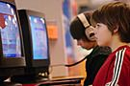

- Enable all students to compete in the global economy.
- Enhance teaching and learning to attain better academic results for all students.
- Help close the achievement gap.

From 2002 through 2006, over $1.4 billion in eRate money was distributed in New York State, and $280 million in federal Title IID, Enhancing Education Through Technology Act (EETT) and state Learning Technology Grant monies. This investment provided a foundation for the use of technology within USNY. The State would be even better served if the investments were made with benefit of a clear shared vision for how technology best affects teaching and learning. A shared understanding for the use of technology will enable these funds to be leveraged more systemically.

The Board of Regents recently completed a year-long study coordinated by a 25-member field-based Technology Policy & Practices Council. The results of the Council’s efforts have provided a framework to move New York State into national leadership around the use of technologies to support teaching and learning. The Council will continue to identify polices for consideration by the Board of Regents, including public-private partnerships needed to accomplish state technology goals.

Our goal is to increase student performance through higher levels of access to advanced technologies and digital delivery systems. To accomplish this, SED will commence the following initiatives:

- Identify best practices in technology integration. Work with BOCES, Regional Information Centers and Big 5 districts to develop guidelines for the acquisition and integration of technologies at the school building and district levels and promote them across the State. Compile examples of successful technology integration in high-performing schools, including the identification of recommended technology tools, and share them across all schools.

- Identify and implement best practices in innovative professional development models for teachers and administrators which engage educators in 21st century technology integration practices. Initiate competitive grant awards for this process, including evaluation across models. ($4 million)

- Establish standards and expectations for the creation of digital content in the State’s museums and cultural organizations for use by the P-16 community. Provide funding to public television to expand creation and distribution of their current web-based, standards–based digital content in key subject areas. ($1 million)

- Enhance the capacity for SED to coordinate and lead activities that will position New York State as a national leader in the use and integration of technologies in schools. ($1 million and 4 new FTE)

- Work with the State Office for Technology (OFT) to build statewide broadband capacity among USNY institutions. Develop a plan to identify SED’s network infrastructure and target those USNY institutions currently lacking high-speed broadband connectivity (including Internet II where appropriate), and close the existing gaps and inequitable access to high-speed networks. Participate with OFT to assure that State fiscal resources for broadband access are directed to underserved USNY institutions. ($1 million)

Expected Gains:

- Students prepared to use 21st century skills.
- Standards for the use of certain technologies, resulting in lower costs to schools, libraries, and museums.
- State and federal technology grant programs focused on a comprehensive vision for the use of technology in teaching and learning.
- Further pre-service and in-service professional development for teachers and administrators that prepares them for increased integration of technology in the classroom.
- Improved State agency collaboration to create digital networks for all public institutions and reducing telecommunications and Internet costs for USNY.
- Increased access to broadband networks and other technology tools to bridge the digital divide between those institutions with fiscal resources and those without.

Requested Resources:

$7.0 Million and 4 FTE.

Strengthening Student Safety

Prevention of Teacher Misconduct - Ethics and Teacher-Students Boundary Curriculum and Training

In order to address the increasing number of cases involving student-teacher boundary issues, the Regents propose developing prevention measures to raise awareness of appropriate teacher conduct, by creating a training and prevention unit. Currently there is no requirement that students preparing to become teachers or administrators take a course in ethical behavior. Contingent upon this measure being included in the approved budget, the Regents will make coursework in ethics and student-teacher boundary issues mandatory for both certified teachers and applicants for teaching certificates.

In collaboration with colleges and other interested parties, this appropriation will fund the development of materials on appropriate student-teacher boundaries and ethics, to increase awareness and reduce the number of teachers involved in violations. The materials will be used pre-certification by colleges and post-certification as professional development. ($850,000 and 10 FTE)
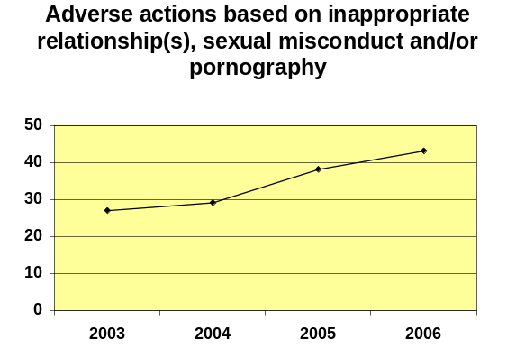

Criminal History Review Unit
The Regents propose to expand the criminal history review unit to support the statutorily mandated processing, review and investigation of fingerprint background checks and subsequent arrest notices along with the resulting prosecution of charges under Part 83 of Commissioner’s Regulations. Several expansions of the scope of the fingerprinting program (most notably non-public and private schools), with no increase in funding or staff for the unit, have created a need for additional staff. ($600,000* and 9 FTE)

Suspension of Teaching Certificates
A Priority Legislative Proposal would authorize the Department to automatically suspend and subsequently revoke teaching certificates of individuals who are convicted of sex-related crimes that are subject to the registration requirements of the Sex Offender Registration Act (SORA). The result will be to expeditiously remove educators convicted of sex crimes from the classroom and the school district’s payroll.

Requested Resources:
$1.45 Million and 19 FTE.

* The $600,000 funding for Criminal History Review could be provided either through an increase in the General Fund appropriation or through a statutory increase of $16 in the fee charged to applicants, in a new Special Revenue Account.
IMPROVE ACHIEVEMENT BY INCREASING ACCESS TO MUSEUMS, CULTURAL INSTITUTIONS AND ON-LINE LIBRARY SERVICES

Cultural and Museum Education Act

Proposed funding will enable museums, historical societies and performing arts institutions in New York State to partner with schools to use cultural resources and programs to support and enhance classroom teaching, close the achievement gap, and give students the skills they need for today’s global economy.

The Proposal: Create a formula-based funding stream for museums based on hours of certified standards-based educational programs, create a competitive grants program to foster innovative standards-based educational programs in museums and performing arts and other cultural institutions, and enable the evaluation and assessment of each component of the Act to ensure accountability and effective programming.

P-16 Action: Increase literacy of children and parents by expanding programs in museums; raise the learning standards to exceed global standards so all students graduate ready for citizenship, work, and continued education.

Expected Gains:

- The number of children who enter school with below-average preliteracy skills will be reduced.
- Parents will be engaged in their children’s learning experience.
- The availability of innovative museum programs will increase by more than 20 percent by September 2009.
- The Office of Cultural Education will establish a clearinghouse for innovative programs and partnerships.

Requested Resources:

$30 million – year one and 5 FTE

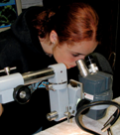
The Cultural and Museum Education Act recognizes that museums are centers of learning and infuses much-needed funds at a time when many museums struggle to keep their doors open.
New York’s museums already serve more than 4.7 million students each year. The programs they provide are an invaluable resource for teachers and students.

IMPROVE ACHIEVEMENT BY INCREASING ACCESS TO MUSEUMS, CULTURAL INSTITUTIONS AND ON-LINE LIBRARY SERVICES

Permanent Statewide Internet Library

Proposed funding will provide a strong foundation for New York’s information infrastructure with information technology, including databases and other digitized resources, that will give New York’s students, businesses, researchers, and universities a competitive edge.

The Proposal: Develop the State’s information infrastructure by investing in a comprehensive Statewide Internet Library to serve higher education, research and development, the business community, and students and educators in K-12. The New York Online Virtual Electronic Library (NOVELNY) is currently a program pilot at www.novelnewyork.org.

P-16 Action: “Raise the learning standards to exceed global standards so all students graduate ready for citizenship, work and continued education” by making extensive on-line resources and standards-aligned content available for teachers and students; support life-long learning for all New York citizens and access to information and resources to achieve that goal.

Expected Gains:

- Increased student reading scores and academic achievement increases in states with access to strong electronic libraries with enhanced learning and student achievement and enriched teaching.
- Greater entrepreneurial success and improved economic productivity.
- Avoidance of duplication of effort and costly infrastructure at the local level.
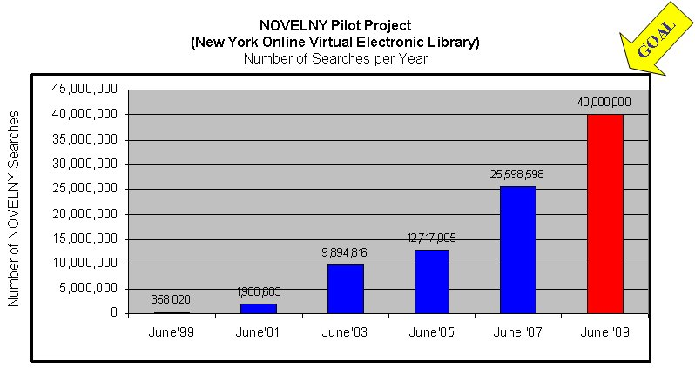

Requested Resources:

$10 million annually and 3 FTE.
IMPROVE ACHIEVEMENT BY INCREASING ACCESS TO MUSEUMS, CULTURAL INSTITUTIONS AND ON-LINE LIBRARY SERVICES

Ensuring the Long-Term Survival and Appropriate Care of the State’s Government Records and Cultural Resources

Proposed funding will enable archives, museums, historical societies, libraries, and public television stations to develop plans for disaster preparedness and preservation of State and local electronic government records. It will provide permanent support for the renovation and construction of public library facilities and for training and support for governing boards of cultural institutions.

The Proposal:

- Public library construction and renovation ($20 million annually).
- Support collaboration and resource sharing among library systems ($3 million and continuation of the $8 million provided in the 2007-2008 appropriation).
- Develop a long-term plan for managing State government records created in electronic form to ensure their preservation and accessibility over time ($500,000).
- Training and tools to ensure State and local governments and cultural institutions are prepared for and can effectively respond to disasters involving collections ($500,000).
- Establish effective training and support programs for governing boards and trustees of non-profit museums, libraries, and public television stations ($750,000 annually).

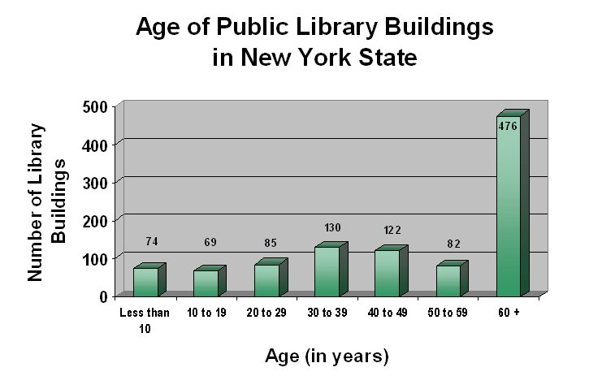

Requested Resources:

$24,750,000 and 12 FTE.
IMPROVE ACHIEVEMENT BY INCREASING ACCESS TO MUSEUMS, CULTURAL INSTITUTIONS AND ON-LINE LIBRARY SERVICES

Cultural Institutions and Resources for Lifelong Literacy, Learning and Workforce Development

Proposed funding will help New York’s libraries, museums, public television stations, archives, and other cultural institutions to improve student achievement, close the performance gap, and give students the skills and information they need for today’s global economy.

The Proposal:

- Programs for families with children from birth to 4 in cultural institutions ($5 million annually).
- Summer reading programs and literacy programs in cultural institutions ($1 million annually).
- Library services and materials for students with disabilities ($800,000 annually).
- Extended hours at the New York State Library and State Archives ($750,000 annually).

Requested Resources:

$7,550,000 and 28 FTE.
ENABLE MORE INDIVIDUALS WITH DISABILITIES TO LIVE AND WORK INDEPENDENTLY

Independent Living Centers

New York’s existing 36 statutorily authorized Independent Living Centers (ILCs) serve over 80,000 individuals and thousands of businesses throughout New York State. They have become the primary resource for information necessary to enhance community integration of people with disabilities, increase physical and communication access and remove disincentives to work. ILCs remain instrumental in facilitating implementation of the U.S. Supreme Court’s Olmstead Decision, creating strategies with school districts for youth to enhance transition planning and services for youth with disabilities. ILCs continue to be the only consumer controlled, community based, nonresidential, not-for-profit network in New York State operating based on self-help, peer driven model.

In 2007-08, State funding was provided for new ILCs in Herkimer, Putnam and Sullivan counties. However, these Centers were not established in statute so their continued funding is not assured. In 2008-09 VESID is seeking:

- to establish in statute these 3 new Centers and one additional Center to focus on successful transition of youths into adult life, job readiness skill development for people entering the job market, and targeted outreach and coordination of de-institutionalization for New Yorkers with disabilities; and
- an additional $5.0 million in ILC funding for 40 statutory ILCs (36 exisitng and 4 new) to serve an additional 7,500 individuals with disabilities.

Requested Resources:

$5 Million

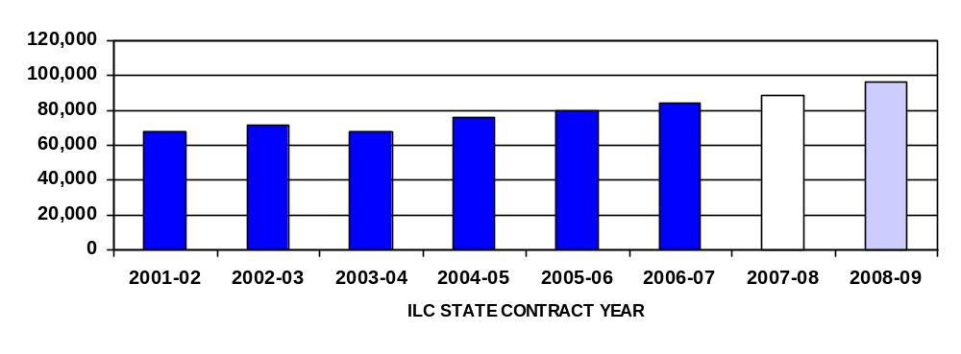
NEW YORK STATE INDEPENDENT LIVING CENTERS

.

People Served

Projection based on current allocation and 3 new centers

Projection based on additional $5 million allocation

ENABLE MORE INDIVIDUALS WITH DISABILITIES TO LIVE AND WORK INDEPENDENTLY

Workers Compensation Rehabilitation Management Services (WCRMS)

VESID is proposing WCRMS to facilitate the expeditious return to work of individuals with disabilities receiving workers compensation benefits. The available services would include but not be limited to: skill assessment, job assessment, retraining, vocational exploration and intensive placement. The injured worker would be referred to VESID by the Workers’ Compensation Board (WCB), State Insurance Fund (SIF), Department of Labor (DOL) or other insurance carrier.

Expected Gains:

  - Access to Vocational Rehabilitation services will enable WC claimants to make more informed choices about returning to work leading to a larger more diverse work force.
  - The partnership with the SIF will allow VESID to see the injured worker quickly, respond to SIF/WCB inquiries, and report to SIF/WCB consistently on actions being taken to help the consumer return to work and the consumer’s actual return to work.
  - It is projected that the average time from VESID eligibility to placement for WC cases will average 10 to 12 months compared to VESID’s general caseload which averages 27 to 28 months.

Requested Resources:

No State funds are requested. Federal funds are being used for this initiative.

Projected Cost Savings and Increased Revenue for New York State
Number of individuals with disabilities who will return to work | 1,600
Value of estimated worker compensation benefit savings per re-employed worker* | $20,000
Projected cost savings over two years | $32,000,000
Estimated annual tax revenue per re-employed worker** | $383
Projected annual increased revenue after two years | $612,800

*Source: VR Database
**Source: VR Database: Projection based on 2006-07Average Annualized Income of VESID Consumers and a NYS tax rate percentage of .022
ENABLE MORE INDIVIDUALS WITH DISABILITIES TO LIVE AND WORK INDEPENDENTLY

Employment of Inmates with Disabilities Returning to Communities

A Memorandum of Understanding (MOU) has been developed with New York State Department of Correctional Services (DOCs) and New York State Division of Parole (DOP). Through this MOU, VESID, DOCs and DOP will collaborate on referral, training and placement activities for inmates with disabilities returning to the community. Counseling and guidance regarding housing, benefits, and transportation will be provided. This initiative will be implemented in New York City, Nassau, Suffolk, and Erie counties for targeted inmate populations determined eligible for VESID services and involved in pre-release activities.

Expected Gains:

  - Approximately 2000 inmates will be eligible for VESID services under this program.
  - Increase in job placement and retention rates.
  - Decrease in recidivism.
  - Collaboration among DOCs, DOP, and VESID in the development of a coordinated process for interagency cross-training, data sharing/analysis, communication and problem solving.

Requested Resources:

No State funds are requested. Federal funds are being used for this initiative.

Projected Cost Savings and Increased Revenue for New York State
Decreased recidivism – Estimated number of inmates with disabilities who, with VESID assistance, will avoid re-incarceration | 1,600
Cost of incarceration of one inmate for 6 months* | $16,000
Projected cost savings over two years | $25,600,000
Estimated number of inmates with disabilities who, with VESID assistance, will be employed after 2 years. | 1,400
Estimated annual tax revenue per employed inmate** | $383
Projected annual increased revenue after two years | $536,200
*Source: NYS Department of Corrections “2002 Releases: Three Year Post Release Follow-Up” Report
**Source: VR Database: Projection based on 2006-07Average Annualized Income of VESID Consumers and a NYS tax rate percentage of .02

Researchers concluded that “Dual enrollment participation had a statistically significant positive association with students’ likelihood of earning a regular high school diploma and enrolling postsecondary education.” This remained true for continuing in college into the second and third years. See Karp, Melinda Mechur, “The Postsecondary Achievement of Participants in Dual Enrollment,” National Research Center for Career and Technical Education, October 2007.

